2. i)

The timeplot of ‘avg’ against time reveals that there is no periodicity. Furthermore the amplitude of the variation does not seem to be increasing or decreasing so taking logarithms is not necessary in this case.

Fitting an ARIMA model to the data yields the following:

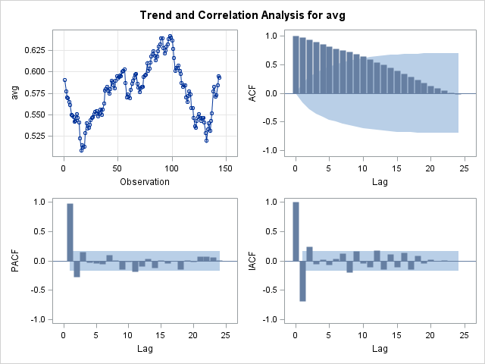

The plot of ‘avg’ against time and the fact that the ACF dies away rather slowly indicate the presence of trend. Therefore differencing is appropriate.

The acf of the series having been differenced once is plausibly that of a stationary process.

(see below)

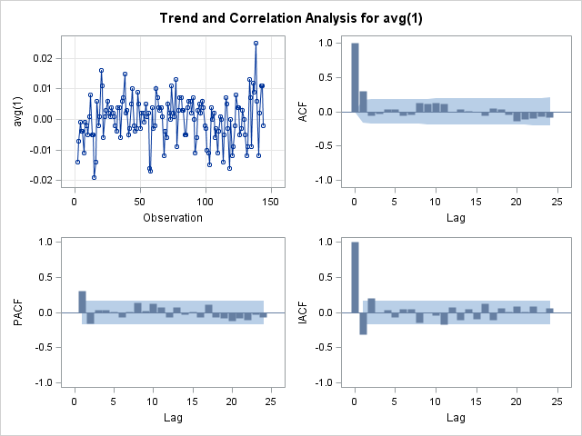

The significant ACF at lag 1 and subsequent cut off suggests that ARIMA (0,1,1) could be appropriate.

The PACF has a cut off after lag 1 (possibly lag 2) suggesting ARIMA (1,1,0) or ARIMA(2,1,0) might be considered.

ARIMA (0,1,1)

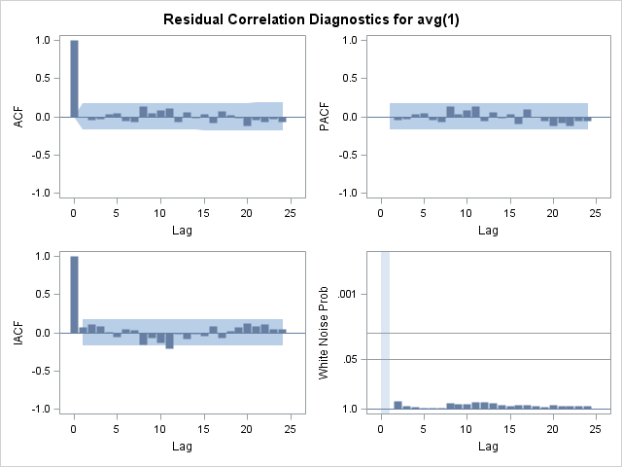

| **Model for variable avg** | |
| --- | --- |
| **Period(s) of Differencing** | 1 |

No mean term in this model.

| **Moving Average Factors** | |
| --- | --- |
| **Factor 1:** | 1 + 0.36347 B**(1) |

ACF and PACF are all look good. No significant values to worry about.

ARIMA (1,1,0)

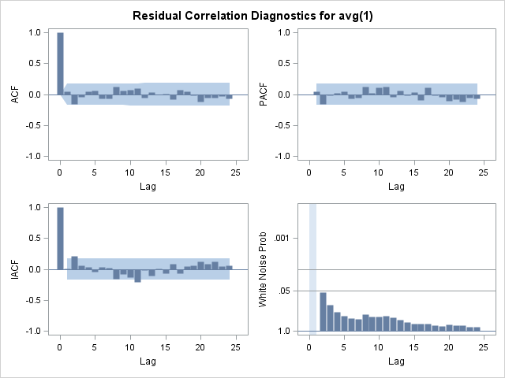

| **Model for variable avg** | |
| --- | --- |
| **Period(s) of Differencing** | 1 |

No mean term in this model.

| **Autoregressive Factors** | |
| --- | --- |
| **Factor 1:** | 1 - 0.29972 B**(1) |

Possible significant ACF and PACF at lag 2.

ARIMA(2,1,0)

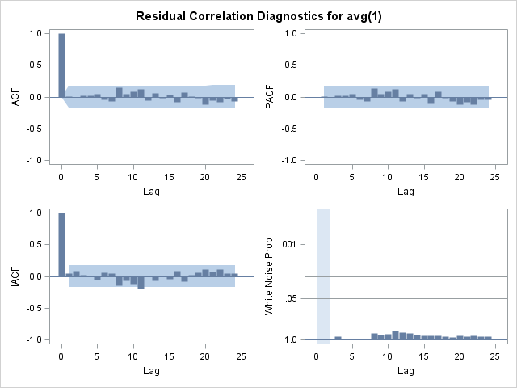

| **Model for variable avg** | |
| --- | --- |
| **Period(s) of Differencing** | 1 |

No mean term in this model.

| **Autoregressive Factors** | |
| --- | --- |
| **Factor 1:** | 1 - 0.34848 B**(1) + 0.16117 B**(2) |

No significant values for the ACF and PACF. The residual plots look good.

**Conclusion**

Here is a summary of the analysis for the three models.

|  |  |  |  |
| --- | --- | --- | --- |
|  | AIC | SBC | Comments |
| ARIMA (2,1,0) | -1012.41 | -1006.48 | No significant ACF or PACF |
| ARIMA (1,1,0) | -1010.72 | -1007.76 | Potentially significant ACF and PACF at lag 2 |
| ARIMA(0,1,1) | -1014.05 | -1011.09 | No significant ACF or PACF |

We would like the AIC and SBC to be as low as possible along with good fitting ACF and PACF plots.

Hence it would be best to pick ARIMA (0,1,1).

The SAS output gives this model as:

| **Moving Average Factors** | |
| --- | --- |
| **Factor 1:** | 1 + 0.36347 B**(1) |

Hence we have:

$$Y_{t}-Y_{t-1}=\left(1+0.36347B\right)ϵ_{t}$$

We can write this explicitly as: $$Y_{t}=Y_{t-1}+ϵ_{t}+0.36347ϵ_{t-1}$$

*where $Y_{t}$ is the ‘average exchange rate during a month’ and $ϵ_{t}$ is a white noise term.*

Looking at the ‘end of month exchange rate’ time-plot, there does not appear to be any seasonality present.

The ACF plot is continuously decreasing and many of these values are highly significant suggesting the presence of trend. Hence the data will be differenced once.

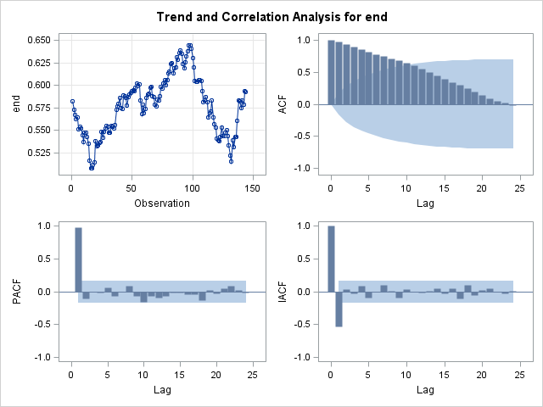

The following plots were obtained after having differenced the data once

There are no significant ACF or PACF terms and no trend is apparent. Hence this can be considered as a white noise process.

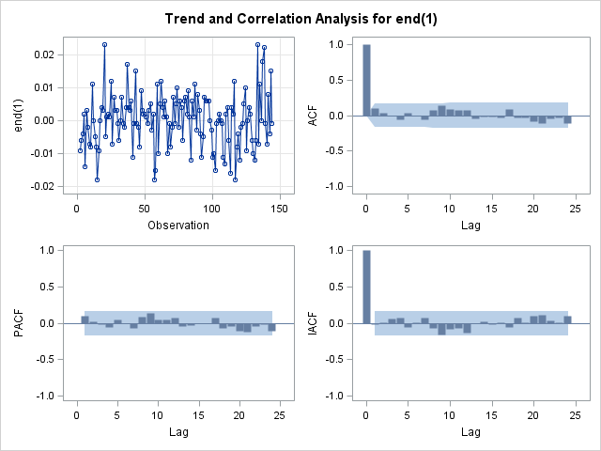

$$X_{t}-X_{t-1}=ϵ_{t}$$

Rearranging gives:

$$X_{t}=X_{t-1}+ϵ_{t}$$

Where $X_{t}$ is the exchange rate at the end of the month and $ϵ_{t}$ is a white noise term.

ARIMA (0,1,0)

b)

Using the coding

**proc** **varmax** data=latdol2;

model end avg /

minic = (type = sbc p = (**0**:**10**) q = **0**) noint dif=(end(**1**) avg(**1**));

**run**;

This checks the SBC for VAR(p) models for the differenced data from p=0 to 10.

| **Minimum Information Criterion Based on SBC** | |
| --- | --- |
| **Lag** | **MA 0** |
| **AR 0** | -20.03825 |
| **AR 1** | -21.06279 |
| **AR 2** | -20.9949 |
| **AR 3** | -20.99498 |
| **AR 4** | -20.91695 |
| **AR 5** | -20.88248 |
| **AR 6** | -20.80145 |
| **AR 7** | -20.73136 |
| **AR 8** | -20.61961 |
| **AR 9** | -20.51829 |
| **AR 10** | -20.45011 |

The lowest of these SBC values is for VAR(1), hence VAR(1) is the best fitting model.

| **Model Parameter Estimates** | | | | | | |
| --- | --- | --- | --- | --- | --- | --- |
| **Equation** | **Parameter** | **Estimate** | **Standard Error** | **t Value** | **Pr > |t|** | **Variable** |
| **end** | **AR1_1_1** | 0.03600 | 0.11185 | 0.32 | 0.7480 | end(t-1) |
|  | **AR1_1_2** | 0.11050 | 0.12356 | 0.89 | 0.3727 | avg(t-1) |
| **avg** | **AR1_2_1** | 0.70995 | 0.07553 | 9.40 | 0.0001 | end(t-1) |
|  | **AR1_2_2** | -0.22236 | 0.08344 | -2.66 | 0.0086 | avg(t-1) |

VAR(1) models take the general form:

$$Z_{t}-μ=Φ_{1}\left(Z_{t-1}-μ\right)+ϵ_{t}$$

where $Z_{t}=\left({x_{t} \atop y_{t}}\right)$, $x_{t}$ is the end value & $y_{t}$ is the average value.

In this case, $Φ_{1}$ = $\left(\begin{matrix}0.03600 & 0.11050 \\ 0.70995 & -0.22236\end{matrix}\right)$

The covariance matrix of the underlying white noise is given by, $Ω=\left(\begin{matrix}0.00007 & 0.00004 \\ 0.00004 & 0.00003\end{matrix}\right)$

$$μ=\left({0.00008 \atop 0.00001}\right)$$

Note: The mean could be considered negligible to 4 significant figures (but the noint operator was used anyway).

Ignoring the negligible mean we have:

$\left({∆x_{t} \atop ∆y_{t}}\right)=\left(\begin{matrix}0.03600 & 0.11050 \\ 0.70995 & -0.22236\end{matrix}\right)\left({x_{t-1} \atop y_{t-1}}\right)+ϵ_{t}$

Where ∆ represents the difference operator (1-L)

This gives us 2 explicit formulae for $x_{t}$& $y_{t}$ in terms of their lag variables.

$${(1-L)x}_{t}=0.03600x_{t-1}+0.11050y_{t-1}+ϵ_{t}$$

$${(1-L)y}_{t}=0.70995x_{t-1}-0.22236y_{t-1}+ς_{t}$$

$(ϵ_{t},ς_{t})$ is a white noise process with estimated covariance matrix $Ω$.(see above)

Rearranging the second equation gives:

$$y_{t}=0.70995x_{t-1}+0.77764y_{t-1}+ς_{t}$$

The portmanteau test statistics show that the coefficients of 0.03600 and 0.11050 are significant at the 5% level.

Forecasts of the exchange rate for first three months of 2006:

| **Forecasts** | | | | | |
| --- | --- | --- | --- | --- | --- |
| **Variable** | **Obs** | **Forecast** | **Standard Error** | **95% Confidence Limits** | |
| **‘End of month’** | **Jan ‘06** | 0.59274 | 0.00810 | 0.57686 | 0.60863 |
|  | **Feb ‘06** | 0.59270 | 0.01204 | 0.56911 | 0.61630 |
|  | **Mar ‘06** | 0.59269 | 0.01530 | 0.56270 | 0.62268 |
| **‘Average’** | **Jan ‘06** | 0.59273 | 0.00547 | 0.58201 | 0.60346 |
|  | **Feb ‘06** | 0.59261 | 0.01102 | 0.57101 | 0.61421 |
|  | **Mar’06** | 0.59261 | 0.01435 | 0.56448 | 0.62074 |

iii)

CODING

**proc** **arima** data=latdol2;

identify var=end(**1**) ;

estimate q=**0** noint;

identify var=avg(**1**) crosscor=end(**1**);

estimate q=**1** input=(**1**$/(**1**)end) noint;

forecast lead=**3** out=results;

**run**;

The first identify statement specifies what is going to be the input variable, here the first difference of the variable end, and produces the ACF and other functions.

The ACF output suggests that we should adopt an ARIMA(0,1,1) model to ‘end’. The first estimate statement fits this model, and the noint option indicates that a zero mean is being assumed (which is justified as the mean is zero to at least 4sf).

The output exhibits the fitted model and the p-values of the portmanteau statistics show that it fits well.

$${∆X}_{t}=η_{t}$$

$$X_{t}-X_{t-1}=η_{t}$$

(as found in 2 i) )

The fitted model for the input process is used:

a) for pre-whitening the input and output variables before calculation of their c.c.f.,

b) for calculating forecast values of the input variable which are in turn used in the

calculation of forecast values of the output variable.

After the input process has been modelled, the second identify statement, with the ‘crosscor’ option, produces i) the ACF and other functions for what is going to be the output variable, the first differences of ‘avg’, and ii) the c.c.f of the first differences of ‘avg’ and ‘end’, automatically pre-whitened using the model fitted to ‘end’ by the previous estimate statement. Examination of the c.c.f indicates that there is a time delay of 1 unit.

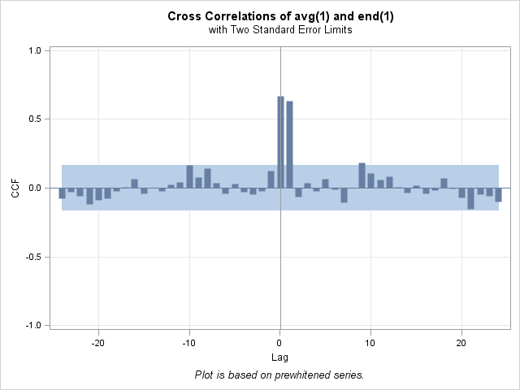

|  |  |
| --- | --- |
| **Variance of transformed series avg** | 0.000054 |
| **Variance of transformed series end** | 0.000066 |

No mean term in this model.

| **Moving Average Factors** | |
| --- | --- |
| **Factor 1:** | 1 - 0.95095 B**(1) |

| **Denominator Factors** | |
| --- | --- |
| **Factor 1:** | 1 + 0.15255 B**(1) |

Transfer function Model is therefore:

$$Y_{t}=\frac{1.107444}{1+0.15255L}X_{t-1}+ϵ_{t}-{0.95095ϵ}_{t-1}$$

The forecasts for each of the three months are:

| **Forecasts for variable avg** | | | | |
| --- | --- | --- | --- | --- |
| **Obs** | **Forecast** | **Std Error** | **95% Confidence Limits** | |
| **Jan ‘06** | 0.5921 | 0.0051 | 0.5821 | 0.6021 |
| **Feb ‘06** | 0.5926 | 0.0103 | 0.5724 | 0.6129 |
| **Mar ‘06** | 0.5925 | 0.0128 | 0.5674 | 0.6177 |